Functional
Specification

V 1.0

Training

Components: Login, Dashboard and Create transactions

Author: Hyusein Tyurkmen
Table of Contents

Introduction 3

Functional requirements 3

Wireframe diagram 4
Introduction

This specification describes the part of the “Online bills payment” project which is related to the Login, Dashboard and Create transactions

Functional requirements

- When the user go to http://www.onlinebills.com he will see the login page with Username, Password and Login button

- A documentation of Create New Registration will be delivered later.

- For valid credentials the user can use username: testuser and password: TestUser1

- When a user provides wrong password or username a red colored message:

”Wrong password or username!” appears

- When a user provides blank password or username a red colored message:

”A blank password or username is provided!” appears

- When the user login successfully he is redirected to the Homepage. See the mockup for more details.

- When the user click on Create transaction a confirmation window with OK and Cancel buttons appears

- When OK button is clicked a green message: “The transaction is completed” appears

- When Cancel button is clicked the confirmation window is closed and the user is turned back to the Homepage

- There is a dropdown list with predefined options of choosing a card already registered from the user

- When the user clicks Logout a confirmation window appears.

- When the user clicks OK to confirm logout its session is killed and the user is redirected to the login page.

- When the user clicks Cancel to reject the logout he is landed back to the last visited page
Wireframe diagram

Login form
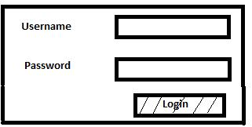

Home page
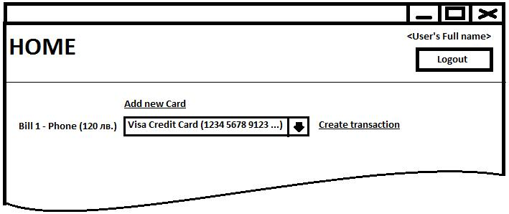

Confirmation dialog
